1. **Consider a “HouseKeeping” database, containing “Staff” table whose schema is as shown below.**

**Create a web page consisting a DropDownList (displaying the StaffID), Label displaying all the details of the selected staff from the DropDownList, ListBox with few cities as items and “Update” button which updates the “City” in the database with the selected city from ListBox. Use disconnected data access.**

**Staff Table Schema and initial data:**

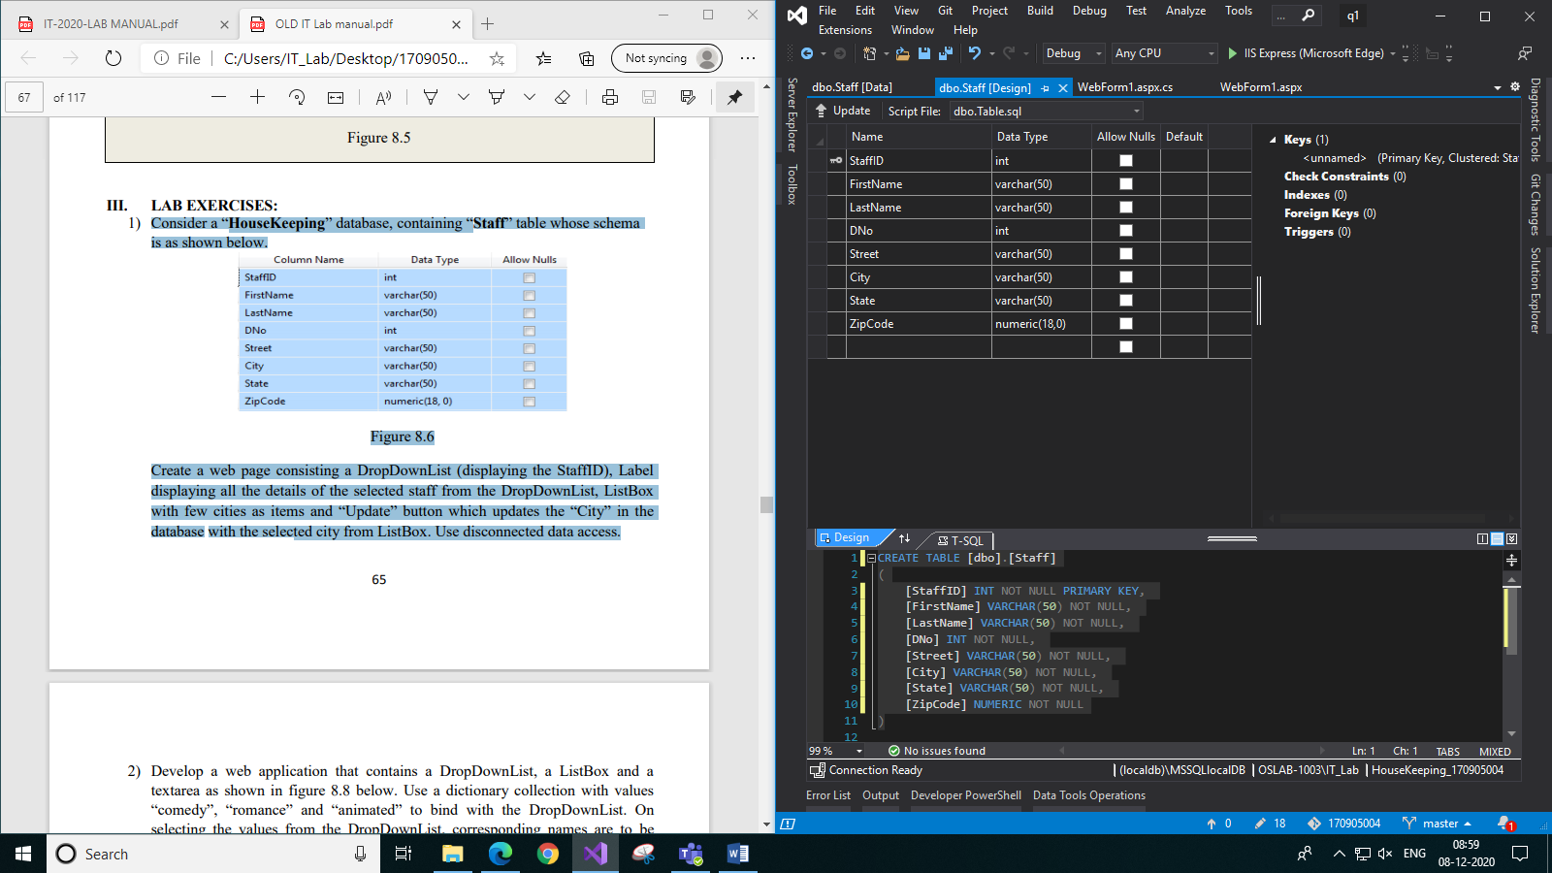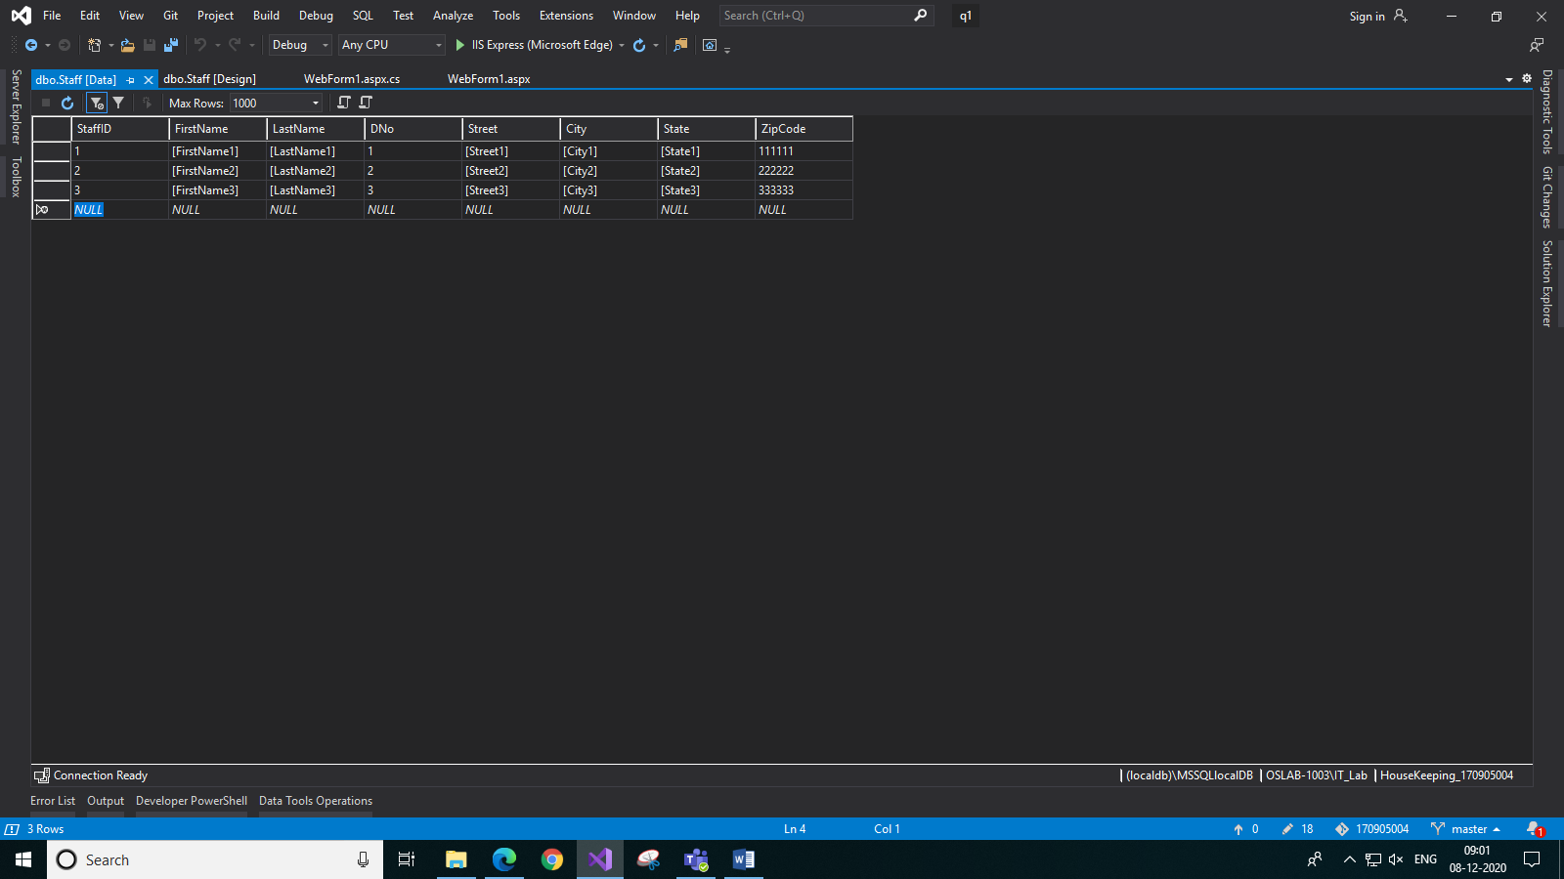

**Code:**

**WebForm1.aspx:**

<%@ Page Language="C#" AutoEventWireup="true" CodeBehind="WebForm1.aspx.cs" Inherits="q1.WebForm1" %>

<!DOCTYPE html>

<html xmlns="http://www.w3.org/1999/xhtml">

<head runat="server">

<title>Staff Details</title>

</head>

<body>

<form id="form1" runat="server" style="text-align: center">

<div>

Select the staff_id:<br />

<asp:DropDownList ID="DropDownList1" runat="server" Height="30px" Width="100px"></asp:DropDownList>

<br /><br />

Select the city:

<br />

<asp:ListBox ID="ListBox1" runat="server" Height="95px" Width="105px">

<asp:ListItem>Bangalore</asp:ListItem>

<asp:ListItem>Manipal</asp:ListItem>

<asp:ListItem>Chennai</asp:ListItem>

<asp:ListItem>Jaipur</asp:ListItem>

<asp:ListItem>Mumbai</asp:ListItem>

</asp:ListBox>

<br /><br />

<asp:Button ID="Button1" runat="server" Text="Update City" Height="30px" Width="100px" OnClick="Button1_Click" />

&nbsp;&nbsp;&nbsp;&nbsp;&nbsp;&nbsp;&nbsp;

<asp:Button ID="Button2" runat="server" Text="View Details" Height="30px" Width="100px" OnClick="Button2_Click" />

<br />

<br />

<asp:Label ID="Label1" runat="server" Text=""></asp:Label>

<br />

<br />

</div>

</form>

</body>

</html>

**WebForm1.aspx.cs:**

using System;

using System.Collections.Generic;

using System.Linq;

using System.Web;

using System.Web.UI;

using System.Web.UI.WebControls;

using System.Data;

using System.Data.Sql;

using System.Data.SqlClient;

namespace q1

{

public partial class WebForm1 : System.Web.UI.Page

{

DataSet ds = new DataSet();

protected void Page_Load(object sender, EventArgs e)

{

if (!this.IsPostBack)

{

SqlConnection con = new SqlConnection();

con.ConnectionString = @"Data Source=(localdb)\MSSQLlocalDB;Initial Catalog=HouseKeeping_170905004;Integrated Security=True";

SqlCommand command = new SqlCommand("SELECT StaffID from Staff", con);

SqlDataAdapter adapter = new SqlDataAdapter(command);

adapter.Fill(ds, "Staff_Names");

DropDownList1.DataSource = ds.Tables["Staff_Names"];

DropDownList1.DataTextField = "StaffID";

DropDownList1.DataBind();

}

}

protected void Button1_Click(object sender, EventArgs e)

{

SqlConnection con = new SqlConnection();

con.ConnectionString = @"Data Source=(localdb)\MSSQLlocalDB;Initial Catalog=HouseKeeping_170905004;Integrated Security=True";

SqlCommand command = new SqlCommand("UPDATE Staff SET City=@City where StaffID=@StaffID", con);

command.Parameters.AddWithValue("@City", ListBox1.SelectedItem.Text);

command.Parameters.AddWithValue("@StaffID", DropDownList1.SelectedItem.Text);

try

{

con.Open();

int count = command.ExecuteNonQuery();

Label1.Text = "Updated " + count + " row";

}

catch (Exception ex)

{

Label1.Text = ex.Message;

}

finally

{

con.Close();

}

}

protected void Button2_Click(object sender, EventArgs e)

{

SqlConnection con = new SqlConnection();

con.ConnectionString = @"Data Source=(localdb)\MSSQLlocalDB;Initial Catalog=HouseKeeping_170905004;Integrated Security=True";

SqlCommand command = new SqlCommand("SELECT * from STAFF where StaffID=@StaffID", con);

command.Parameters.AddWithValue("@StaffID", DropDownList1.SelectedItem.Text);

SqlDataAdapter adapter = new SqlDataAdapter(command);

adapter.Fill(ds, "Staff_Details");

Label1.Text = "<b>" + "Details: " + "<br/>";

foreach(DataColumn col in ds.Tables["Staff_Details"].Columns)

{

Label1.Text += col.ColumnName + "&emsp;&emsp;&ensp;";

}

Label1.Text += "</b>" + "<br/>";

foreach(DataRow row in ds.Tables["Staff_Details"].Rows)

{

Label1.Text += row[0].ToString() + "&emsp;&emsp;&ensp;";

Label1.Text += row[1].ToString() + "&emsp;&emsp;&ensp;";

Label1.Text += row[2].ToString() + "&emsp;&emsp;&ensp;";

Label1.Text += row[3].ToString() + "&emsp;&emsp;&ensp;";

Label1.Text += row[4].ToString() + "&emsp;&emsp;&ensp;";

Label1.Text += row[5].ToString() + "&emsp;&emsp;&ensp;";

Label1.Text += row[6].ToString() + "&emsp;&emsp;&ensp;";

Label1.Text += row[7].ToString() + "<br/>";

}

}

}

}

**Output:**

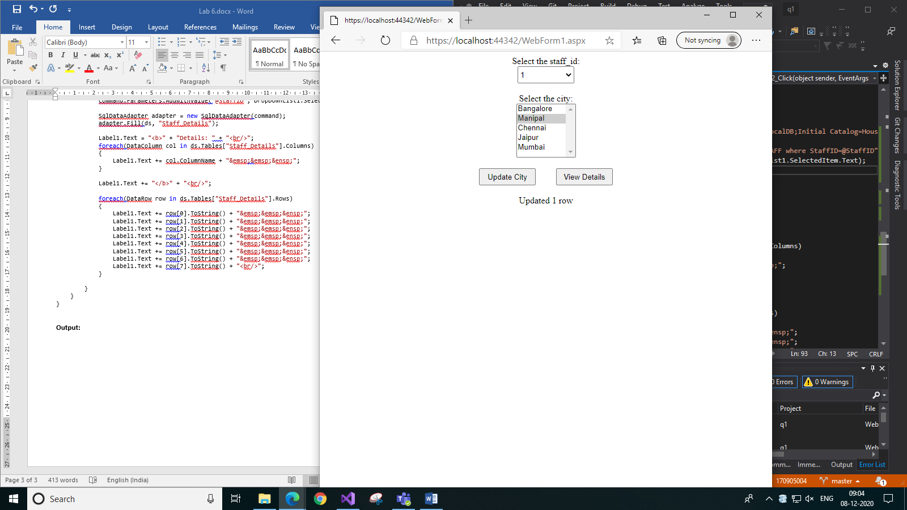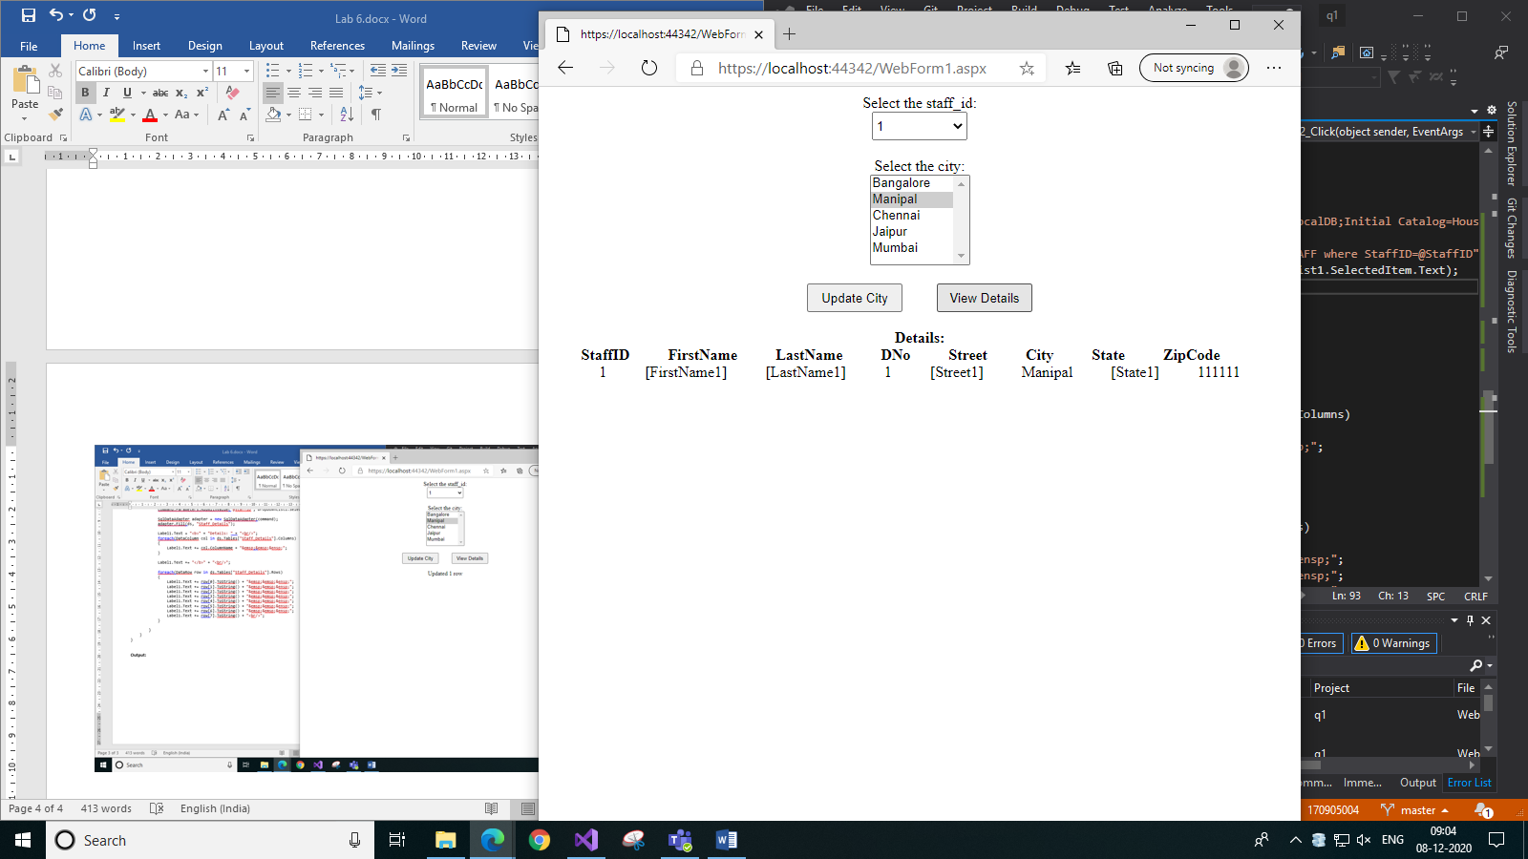

1. *On clicking Update City button b) On clicking View Details button*
2. **Develop a web application that contains a DropDownList, a ListBox and a textarea as shown in figure 8.8 below. Use a dictionary collection with values “comedy”, “romance” and “animated” to bind with the DropDownList. On selecting the values from the DropDownList, corresponding names are to be retrieved from the table “Legends” in the database “Test” using direct data access and those are to be bound with the ListBox. The schema of the table “Legends” from “Test” is shown in figure 8.7. The textarea should display the name and age of the ListBox selection as shown in figure 8.8. Use appropriate data source controls for binding the textarea.**

**Legends Table Schema and Data:**

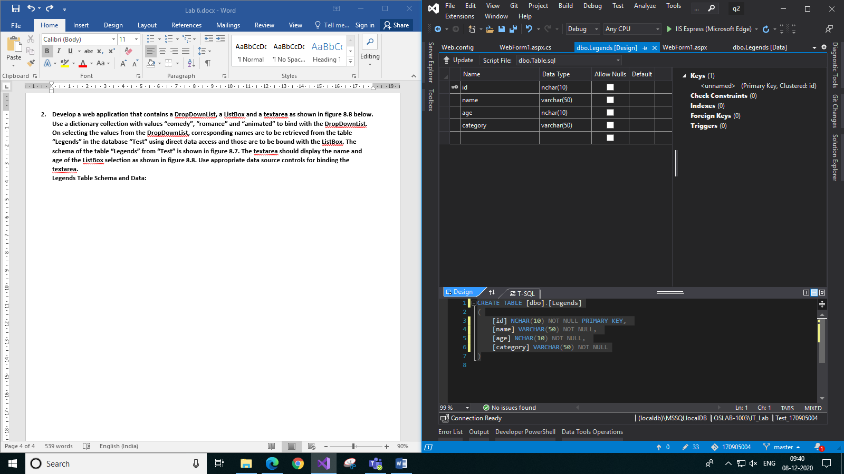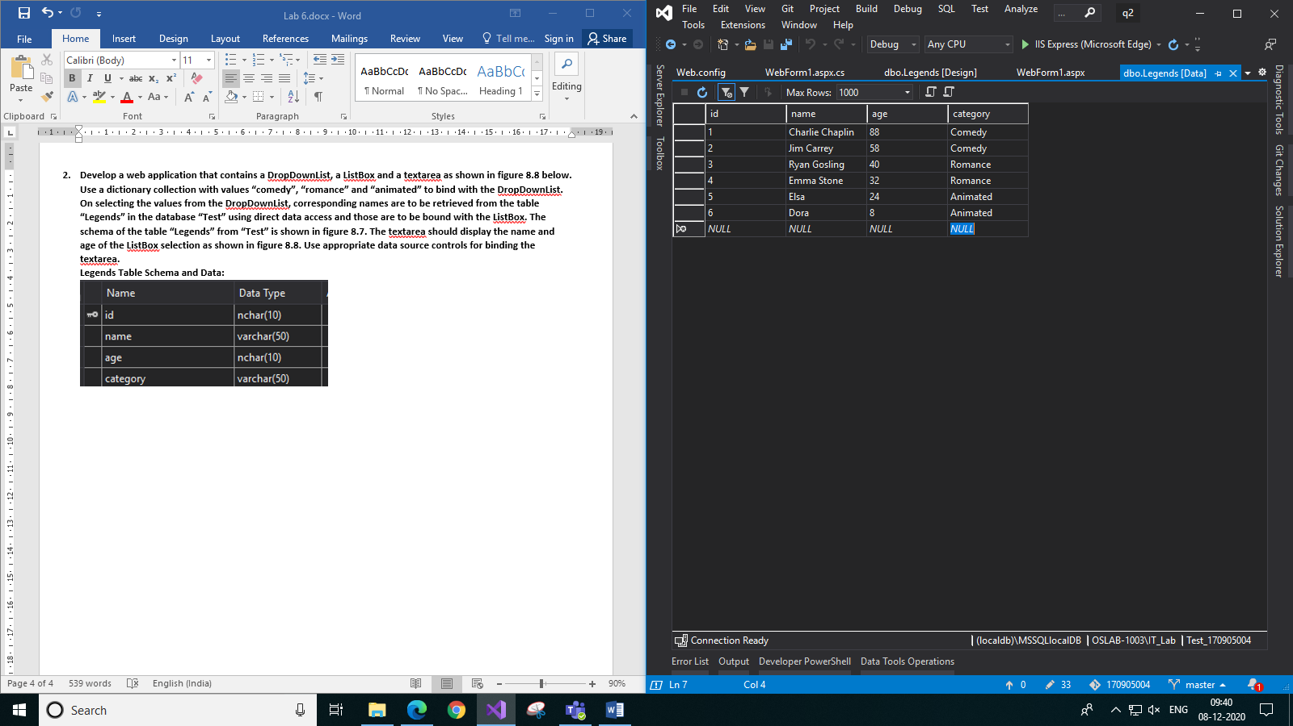

**Code:**

**WebForm1.aspx:**

<%@ Page Language="C#" AutoEventWireup="true" CodeBehind="WebForm1.aspx.cs" Inherits="q2.WebForm1" %>

<!DOCTYPE html>

<html xmlns="http://www.w3.org/1999/xhtml">

<head runat="server">

<title>Legends</title>

</head>

<body>

<form id="form1" runat="server">

<div style="text-align: center; margin-left: auto; margin-right: auto">

Choose the genre: &nbsp;&nbsp;

<asp:DropDownList ID="DropDownList1" runat="server" Height="30px" Width="100px" style="vertical-align: middle" AutoPostBack="True" OnSelectedIndexChanged="DropDownList1_SelectedIndexChanged"></asp:DropDownList>

<br />

<br />

<asp:ListBox ID="ListBox1" runat="server" Height="120px" Width="150px" AutoPostBack="True" ></asp:ListBox>

<br />

<br />

<asp:SqlDataSource ID="SqlDataSource1" runat="server" ConnectionString="<%$ ConnectionStrings:Test_170905004ConnectionString %>" SelectCommand="SELECT name, age FROM Legends WHERE name=@Name and category=@Category">

<SelectParameters>

<asp:ControlParameter ControlID="ListBox1" Name="Name" PropertyName="SelectedItem.Text" Type="String" />

<asp:ControlParameter ControlID="DropDownList1" Name="Category" PropertyName="SelectedItem.Text" Type="String" />

</SelectParameters>

</asp:SqlDataSource>

<asp:Label ID="Label1" runat="server" Text=""></asp:Label>

<br />

<asp:GridView ID="GridView1" runat="server" BackColor="White" BorderColor="#CCCCCC" BorderStyle="None" BorderWidth="1px" CellPadding="4" DataSourceID="SqlDataSource1" ForeColor="Black" GridLines="Horizontal" AutoGenerateColumns="False" style=" margin-left: auto; margin-right: auto">

<Columns>

<asp:TemplateField>

<ItemTemplate>

<b>Name: </b>

<%#Eval("name") %>

<br />

<b>Age: </b>

<%#Eval("age") %>

</ItemTemplate>

</asp:TemplateField>

</Columns>

<FooterStyle BackColor="#CCCC99" ForeColor="Black" />

<HeaderStyle BackColor="#333333" Font-Bold="True" ForeColor="White" />

<PagerStyle BackColor="White" ForeColor="Black" HorizontalAlign="Right" />

<SelectedRowStyle BackColor="#CC3333" Font-Bold="True" ForeColor="White" />

<SortedAscendingCellStyle BackColor="#F7F7F7" />

<SortedAscendingHeaderStyle BackColor="#4B4B4B" />

<SortedDescendingCellStyle BackColor="#E5E5E5" />

<SortedDescendingHeaderStyle BackColor="#242121" />

</asp:GridView>

</div>

</form>

</body>

</html>

**WebForm1.aspx.cs:**

using System;

using System.Collections.Generic;

using System.Data.SqlClient;

using System.Linq;

using System.Web;

using System.Web.UI;

using System.Web.UI.WebControls;

using System.Data;

using System.Data.Sql;

using System.Configuration;

namespace q2

{

public partial class WebForm1 : System.Web.UI.Page

{

protected void Page_Load(object sender, EventArgs e)

{

if (!this.IsPostBack)

{

//Create dictionary of genres

Dictionary<int, string> genres = new Dictionary<int, string>();

genres.Add(0, "");

genres.Add(1, "Comedy");

genres.Add(2, "Romance");

genres.Add(3, "Animated");

//bind dictionary to dropdownlist

DropDownList1.DataTextField = "Value";

DropDownList1.DataValueField = "Key";

DropDownList1.DataSource = genres;

DropDownList1.DataBind();

DropDownList1.SelectedIndex = -1;

}

}

protected void DropDownList1_SelectedIndexChanged(object sender, EventArgs e)

{

ListBox1.Items.Clear();

SqlConnection con = new SqlConnection();

con.ConnectionString = ConfigurationManager.ConnectionStrings["Test_170905004ConnectionString"].ConnectionString;

try

{

con.Open();

SqlCommand command = new SqlCommand("SELECT name from Legends WHERE category=@category", con);

command.Parameters.AddWithValue("@category", DropDownList1.SelectedItem.Text);

SqlDataReader reader;

reader = command.ExecuteReader();

while (reader.Read())

{

ListBox1.Items.Add(reader["name"].ToString());

}

}

catch(Exception ex)

{

Label1.Text = ex.Message;

}

finally

{

con.Close();

}

}

}

}

**Output:**

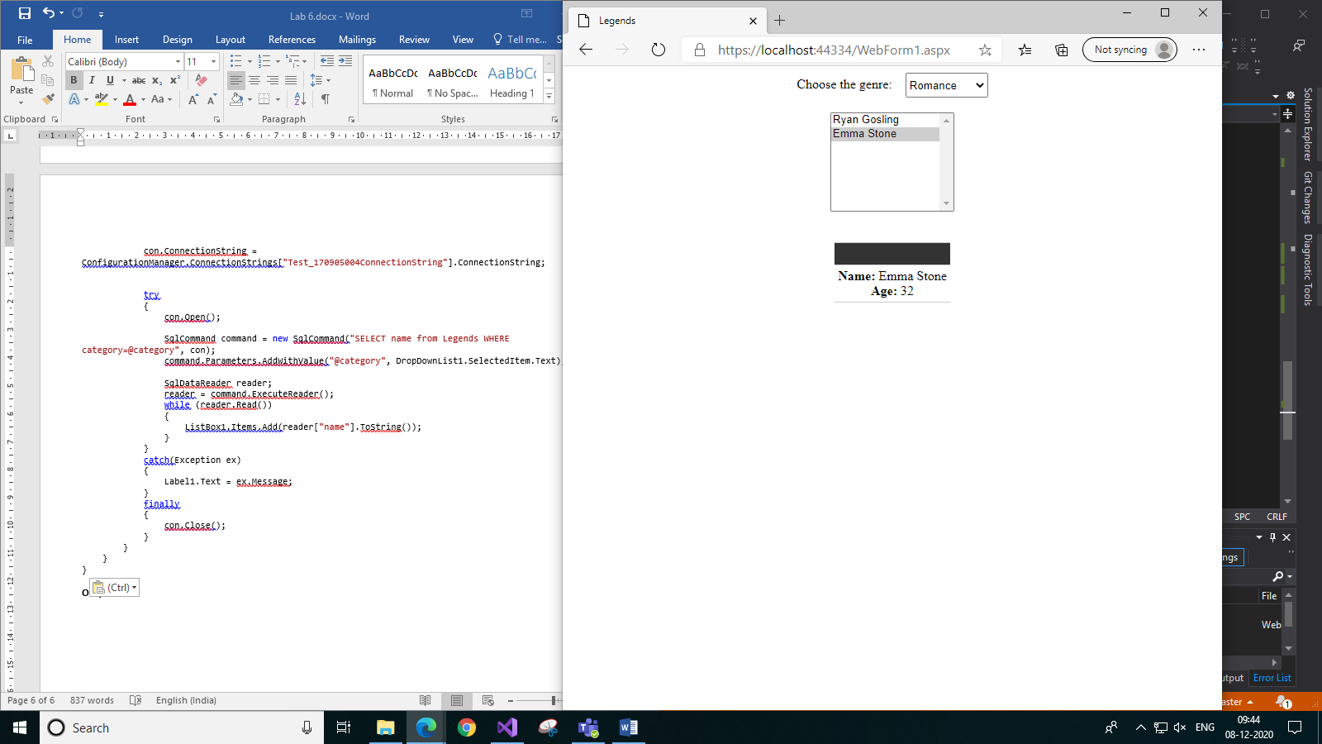 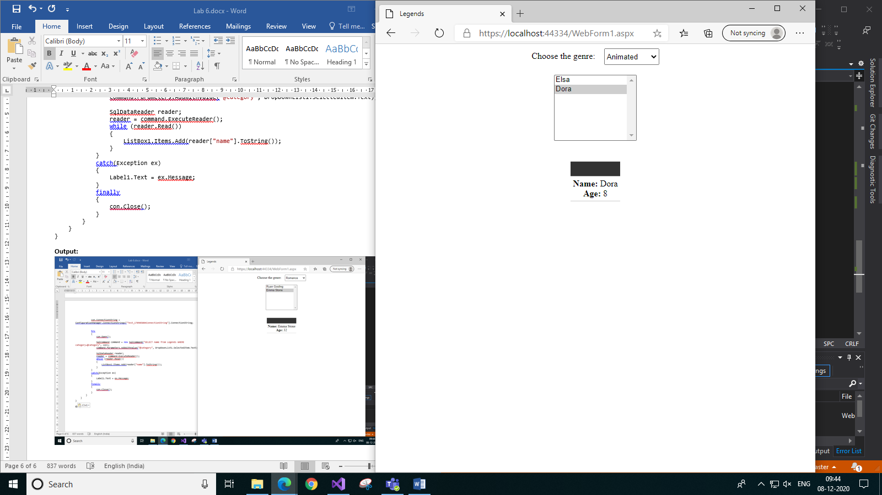

1. *Choosing Romance genre b) Choosing Animated genre*
2. **Consider the schema in figure 8.9 for table “Items” in the database “Products.” 67 Figure 8.9 Figure 8.10 Modifying the price of “Vanilla” to the value taken from a TextBox and update the database. Use direct data access and parameterized commands.**

**Items Table Schema and Data:**

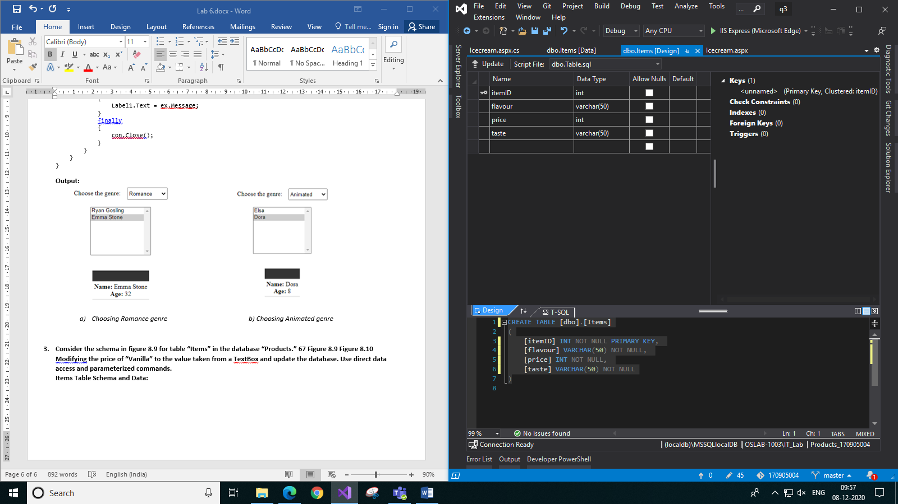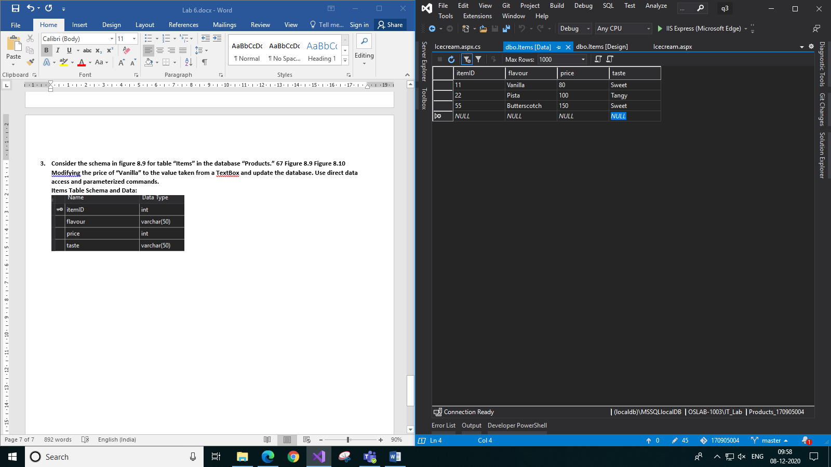

**Code:**

**Icecream.aspx:**

<%@ Page Language="C#" AutoEventWireup="true" CodeBehind="Icecream.aspx.cs" Inherits="q3.Icecream" %>

<!DOCTYPE html>

<html xmlns="http://www.w3.org/1999/xhtml">

<head runat="server">

<title>Icecreams</title>

</head>

<body>

<form id="form1" runat="server">

<div style="text-align: center">

Price of Vanilla icecream:

<asp:Label ID="Label1" runat="server" Text=""></asp:Label>

<br />

<br />

Enter new price of Vanilla icecream:

<asp:TextBox ID="TextBox1" runat="server" style="vertical-align:middle" Height="25px"></asp:TextBox>

<br />

<br />

<asp:Button ID="Button1" runat="server" Text="Update" OnClick="Button1_Click" Height="30px" Width="75px" />

</div>

</form>

</body>

</html>

**Icecream.aspx.cs:**

using System;

using System.Collections.Generic;

using System.Linq;

using System.Web;

using System.Web.UI;

using System.Web.UI.WebControls;

using System.Data;

using System.Data.SqlClient;

using System.Data.Sql;

namespace q3

{

public partial class Icecream : System.Web.UI.Page

{

protected void Page_Load(object sender, EventArgs e)

{

if (!this.IsPostBack)

{

SqlConnection con = new SqlConnection();

con.ConnectionString = @"Data Source=(localdb)\MSSQLlocalDB;Initial Catalog=Products_170905004;Integrated Security=True";

try

{

con.Open();

SqlCommand command = new SqlCommand("SELECT price FROM Items WHERE itemID=11", con);

SqlDataReader reader;

reader = command.ExecuteReader();

while (reader.Read())

{

Label1.Text = reader["price"].ToString();

}

}

catch (Exception ex)

{

Label1.Text = ex.Message;

}

finally

{

con.Close();

}

}

}

protected void Button1_Click(object sender, EventArgs e)

{

SqlConnection con = new SqlConnection();

con.ConnectionString = @"Data Source=(localdb)\MSSQLlocalDB;Initial Catalog=Products;Integrated Security=True";

try

{

con.Open();

SqlCommand command = new SqlCommand("UPDATE Items SET price=@price where itemID=11; SELECT price FROM Items WHERE itemID=11", con);

command.Parameters.AddWithValue("@price", TextBox1.Text);

SqlDataReader reader;

reader = command.ExecuteReader();

while (reader.Read())

{

Label1.Text = reader["price"].ToString();

}

}

catch (Exception ex)

{

Label1.Text = ex.Message;

}

finally

{

con.Close();

}

}

}

}

**Output:**

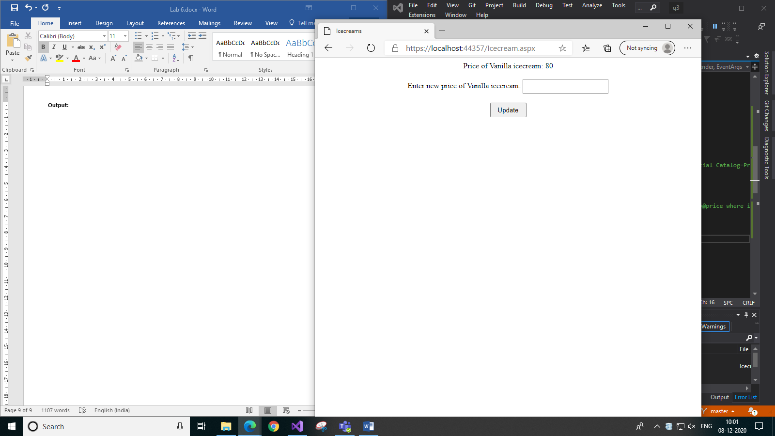*a) Before updating*

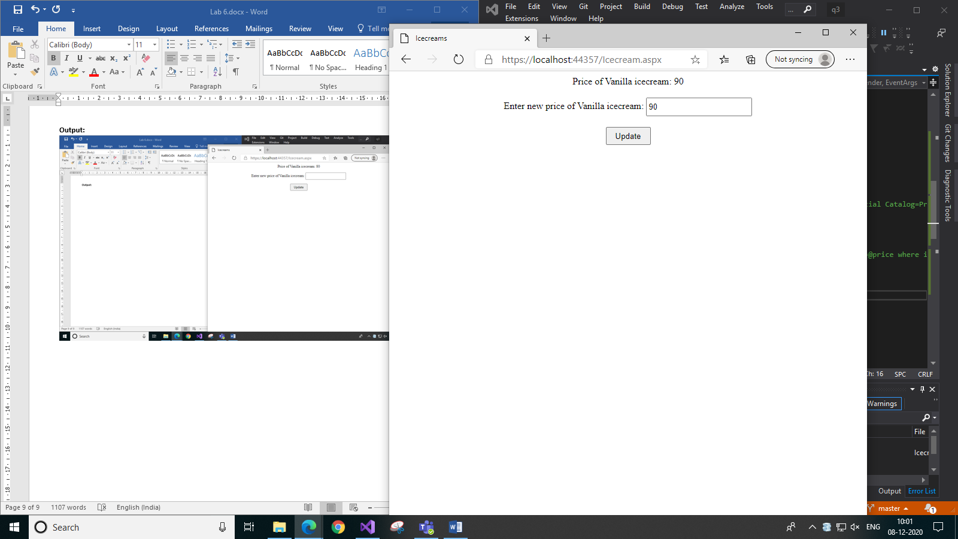*b) After updating*

1. **Consider the following tables: WORKS(person-name,Company-name,Salary) LIVES(Person_name, Street, City) Assume Table data suitably. Design an ASP.NET webpage and include an option to insert data into WORKS table by accepting data from the user using TextBoxes. Also, include an option to retrieve the names of people who work for a particular company along with the cities they live in (particular company name must be accepted from the user). Use the Direct Data Access method to retrieve values from the Database.**

**Works Table schema and data:**

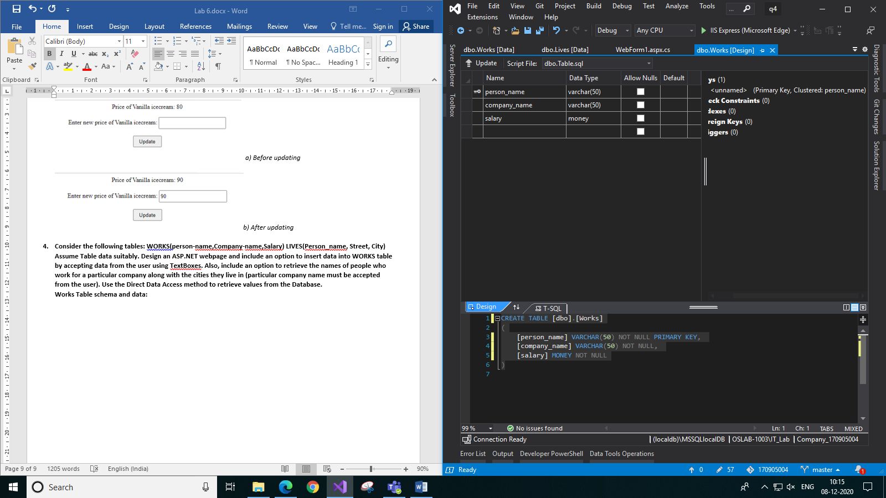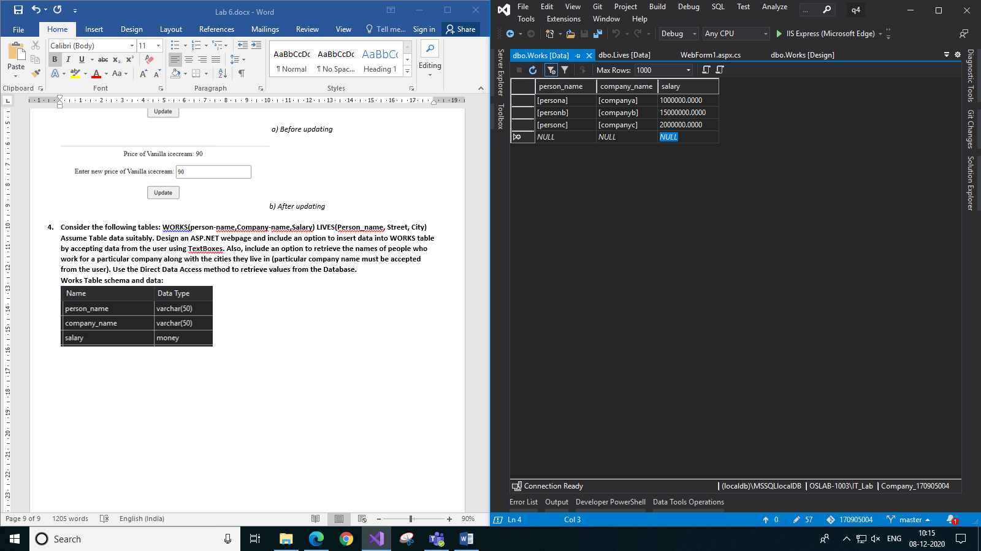

**Lives Table schema and data:**

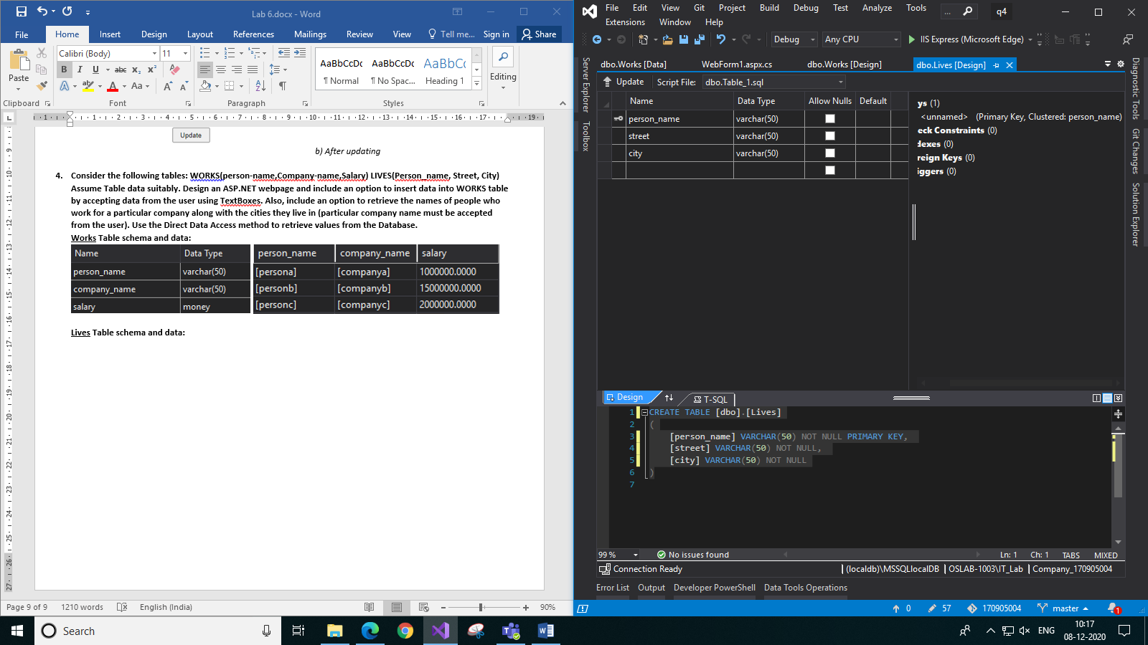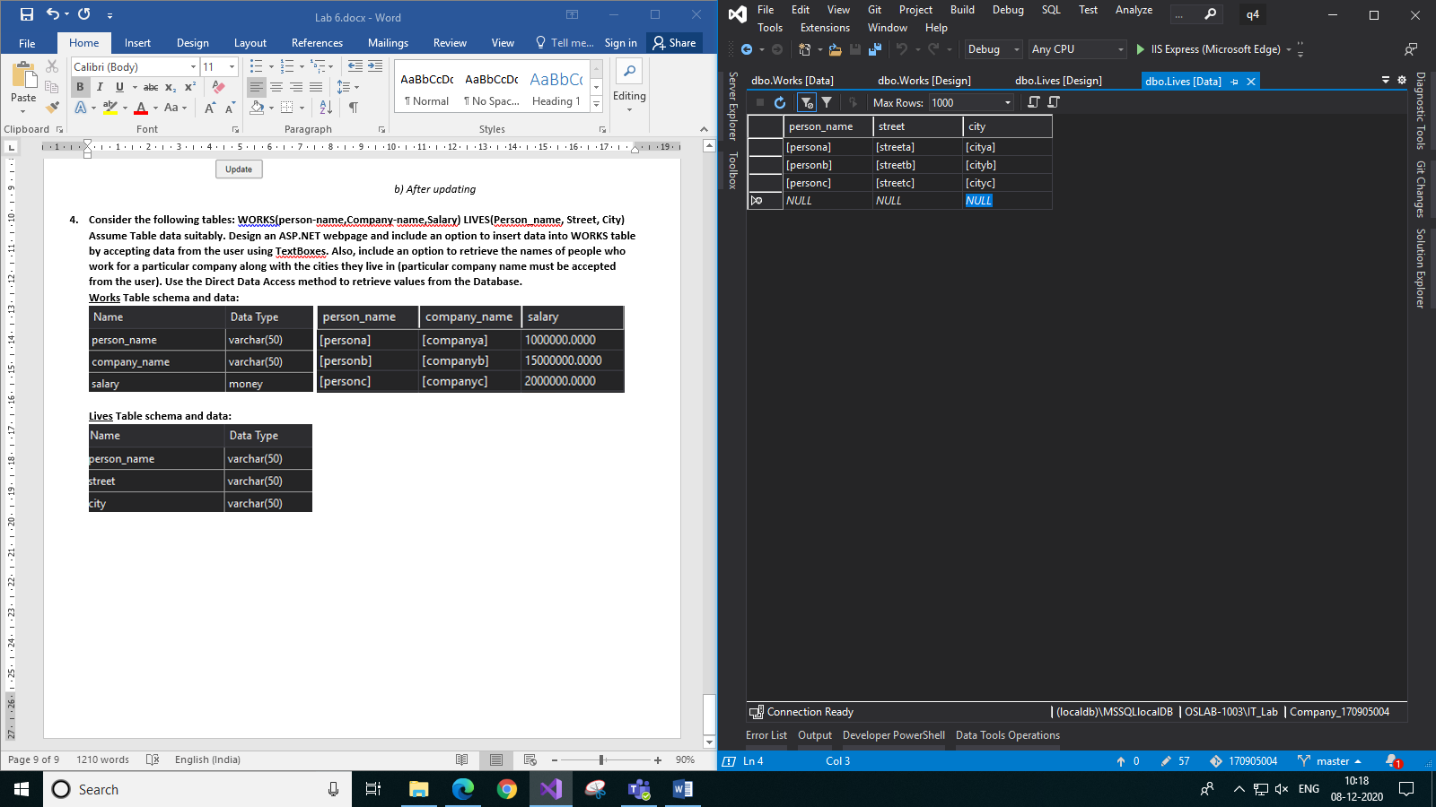

**Code:**

**WebForm1.aspx:**

<%@ Page Language="C#" AutoEventWireup="true" CodeBehind="WebForm1.aspx.cs" Inherits="q4.WebForm1" Theme="Textbox" %>

<!DOCTYPE html>

<html xmlns="http://www.w3.org/1999/xhtml">

<head runat="server">

<title>Employee Information</title>

</head>

<body>

<form id="form1" runat="server">

<div style="padding: 10px; text-align: center; width: 244px; top: 20px; position: absolute">

<h2> INSERT DATA</h2>

Name:

<asp:TextBox ID="TextBox1" runat="server"></asp:TextBox>

<br />

<br />

Company: <asp:TextBox ID="TextBox2" runat="server"></asp:TextBox>

<br />

<br />

Salary:

<asp:TextBox ID="TextBox3" runat="server"></asp:TextBox>

<br />

<br />

Street Name:

<asp:TextBox ID="TextBox4" runat="server"></asp:TextBox>

<br />

<br />

City Name: <asp:TextBox ID="TextBox5" runat="server"></asp:TextBox>

<br />

<br />

<asp:Button ID="Button1" runat="server" Text="Insert" OnClick="Button1_Click" />

<br />

<br />

<asp:Label ID="Label2" runat="server" Text=""></asp:Label>

</div>

<div style="padding: 10px; text-align: center; width: 244px; top: 20px; left: 300px; position: absolute">

<h2>RETRIEVE DATA</h2>

Company:

<asp:TextBox ID="TextBox6" runat="server"></asp:TextBox>

<br />

<br />

<asp:Button ID="Button2" runat="server" Text="Retrieve" OnClick="Button2_Click" />

<br />

<br />

<asp:Label ID="Label1" runat="server" Text=""></asp:Label>

</div>

</form>

</body>

</html>

**WebForm1.aspx.cs:**

using System;

using System.Collections.Generic;

using System.Linq;

using System.Web;

using System.Web.UI;

using System.Web.UI.WebControls;

using System.Data.Sql;

using System.Data;

using System.Data.SqlClient;

namespace q4

{

public partial class WebForm1 : System.Web.UI.Page

{

protected void Page_Load(object sender, EventArgs e)

{

Label1.Text = "";

Label2.Text = "";

}

protected void Button1_Click(object sender, EventArgs e)

{

SqlConnection con = new SqlConnection();

con.ConnectionString = @"Data Source=(localdb)\MSSQLlocalDB;Initial Catalog=Company_170905004;Integrated Security=True";

SqlCommand com = new SqlCommand("INSERT INTO Works(person_name, company_name, salary) VALUES(@name, @company, @salary); INSERT INTO LIVES(person_name, street, city) VALUES(@name, @street, @city)", con);

com.Parameters.AddWithValue("@name", TextBox1.Text);

com.Parameters.AddWithValue("@company", TextBox2.Text);

com.Parameters.AddWithValue("@salary", TextBox3.Text);

com.Parameters.AddWithValue("@street", TextBox4.Text);

com.Parameters.AddWithValue("@city", TextBox5.Text);

try

{

con.Open();

com.ExecuteNonQuery();

Label2.Text = "Record successfuly inserted";

TextBox1.Text = "";

TextBox2.Text = "";

TextBox3.Text = "";

TextBox4.Text = "";

TextBox5.Text = "";

TextBox6.Text = "";

}

catch(Exception ex)

{

Label2.Text = ex.Message;

}

finally

{

con.Close();

}

}

protected void Button2_Click(object sender, EventArgs e)

{

SqlConnection con = new SqlConnection();

con.ConnectionString = @"Data Source=(localdb)\MSSQLlocalDB;Initial Catalog=Company_170905004;Integrated Security=True";

SqlCommand com = new SqlCommand("SELECT L.person_name, city FROM Works W, Lives L where W.person_name=L.person_name and W.company_name = @company", con);

com.Parameters.AddWithValue("@company", TextBox6.Text);

SqlDataReader reader;

try

{

con.Open();

reader = com.ExecuteReader();

Label1.Text = "Details of employees working in " + TextBox6.Text + " are: " + "<br/>";

while (reader.Read())

{

Label1.Text += reader["person_name"] + " lives in " + reader["city"] + "<br/>";

}

TextBox1.Text = "";

TextBox2.Text = "";

TextBox3.Text = "";

TextBox4.Text = "";

TextBox5.Text = "";

TextBox6.Text = "";

}

catch (Exception ex)

{

Label1.Text = ex.Message;

}

finally

{

con.Close();

}

}

}

}

**Output:**

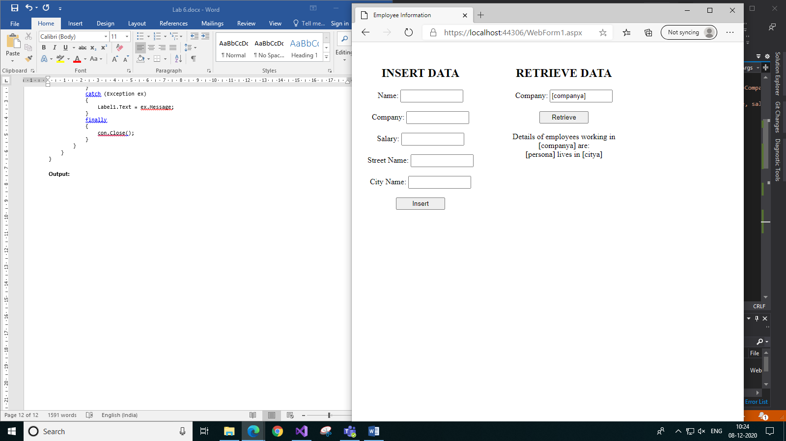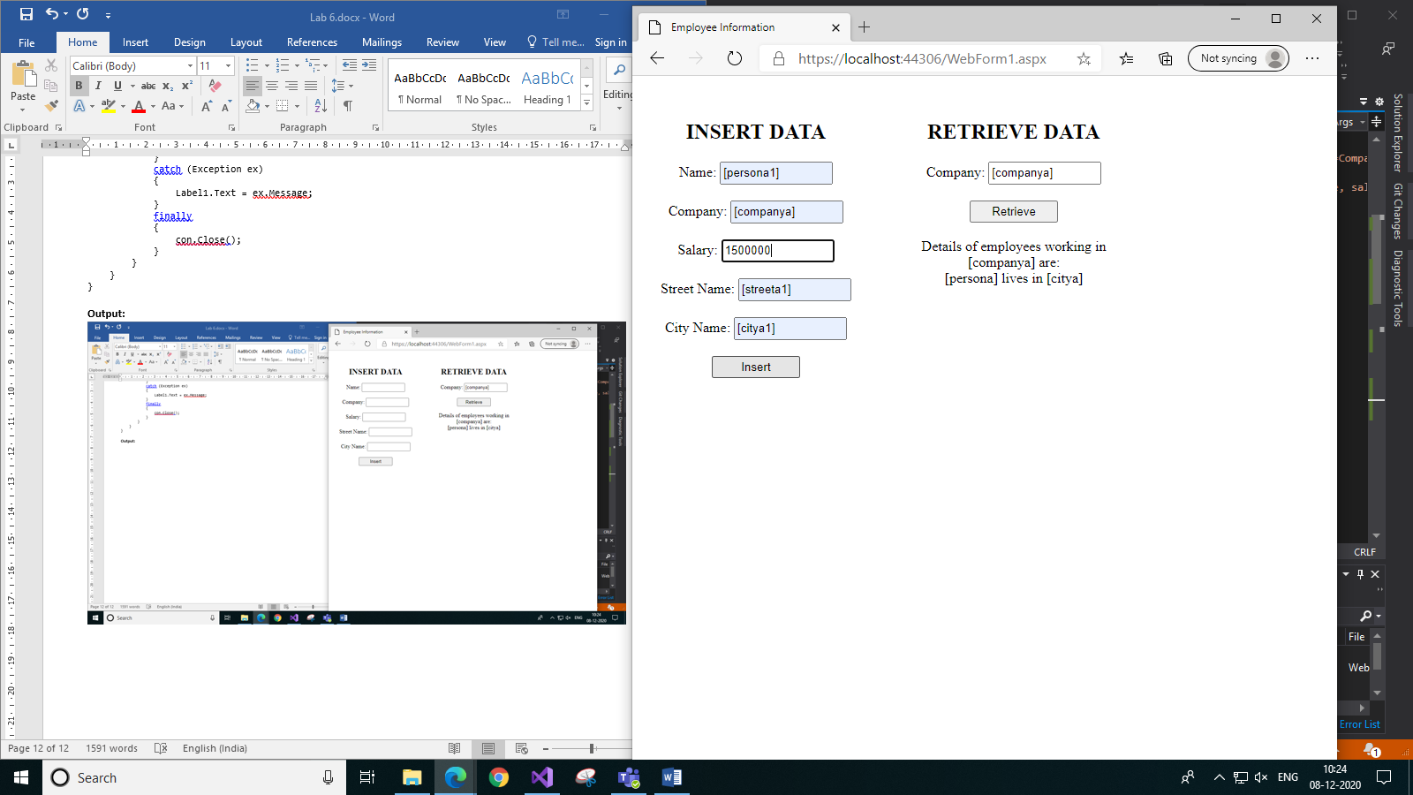

1. *Retrieving data before inserting b) Inserting data*

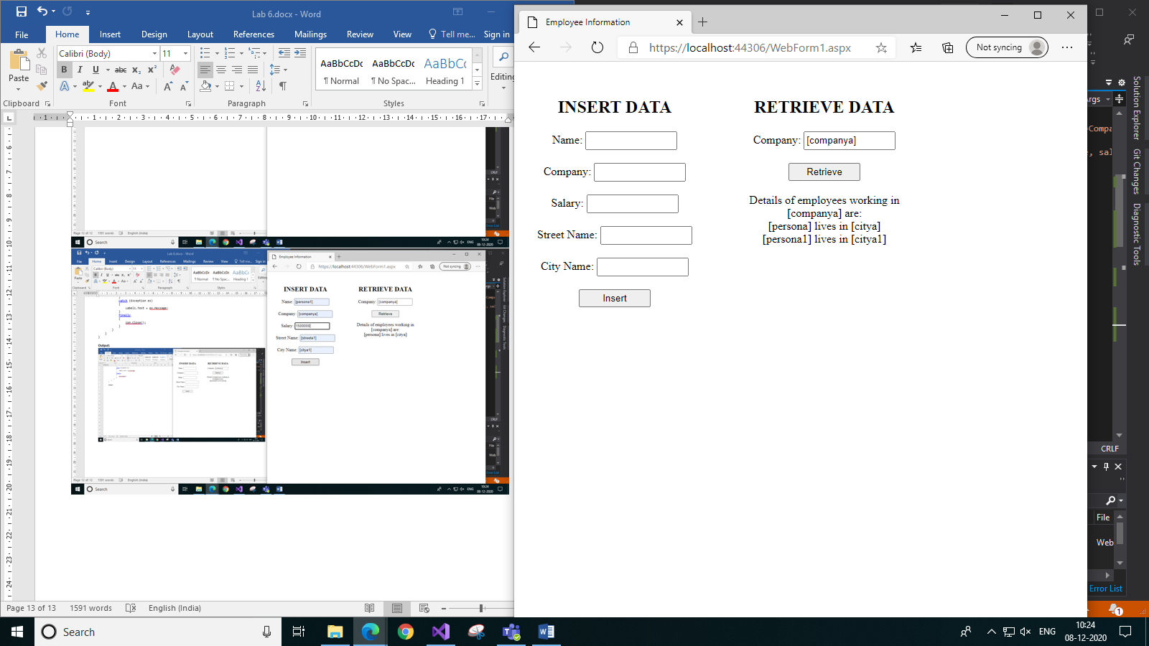

1. *Retrieving data after insert*